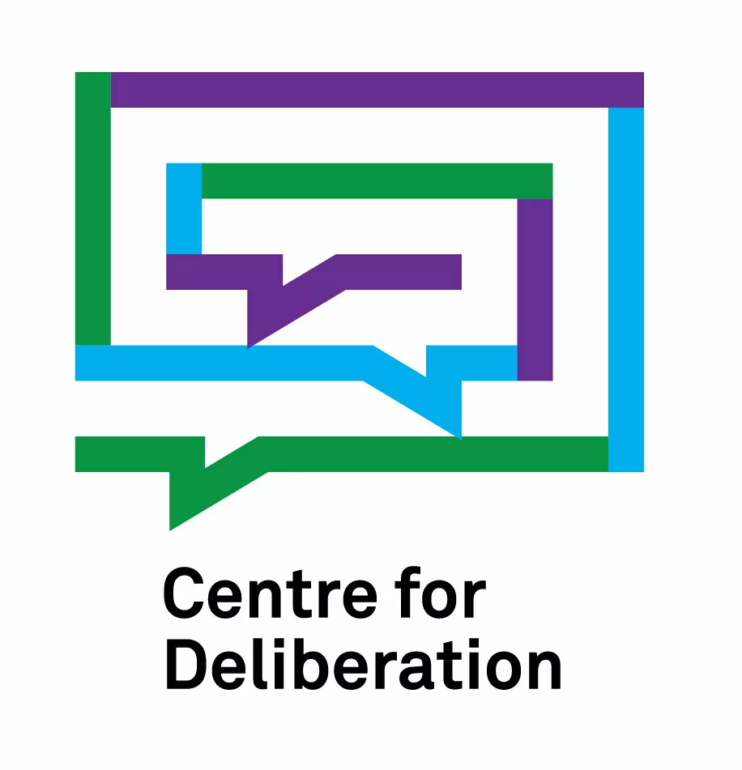

Doctoral position

The Center for Deliberation at the Faculty of Sociology, University of Warsaw, offers employment for a junior researcher wishing to write a Ph.D. dissertation in the framework of the Intersectional Spaces of Participation: Inclusive, Resilient, Embedded (INSPIRE) project.

A consortium of seventeen institutions from eleven European countries is implementing the project led by the University of Birmingham. We invite you to read a short description of the research focus and approach.

The junior researcher will participate, among others, in the design of an interaction framework, including game-like and play-like procedures to engage refugees in communication about the systemic support offered by the host country's institutions. They will be expected to prepare a doctoral dissertation using data from the project, determining its specific topic.
The tasks of the junior researcher will also include participation in project meetings, organizing meetings, and other administrative work (approximately 10% of the total time).

The employment period will be from October 1, 2024, to March 31, 2027.
16 hours per week.
Salary: PLN 4,200 gross a month (plus the 13th salary and additional social bonuses).

Expectations towards candidates:
- Master's degree in sociology or related disciplines,
- knowledge of social research methodology confirmed by practice,
- knowledge of English at least at B2 level.
- Knowledge of Ukrainian and Russian will be an advantage.

If you wish to apply for a position, please send your CV and cover letter to the email a.przybylska@uw.edu.pl (subject: INSPIRE young researcher) by May 10, 2024.
We will invite selected candidates to an online meeting on May 13 (time to be given later).

